**GLOBAL POSITION SYSTEM ( G P S )**

**About GPS**

Global Positioning System (GPS) technology is changing the way we work and play. You can use GPS technology when you are driving, flying, fishing, sailing, hiking, running, biking, working, or exploring. With a GPS receiver, you have an amazing amount of information at your fingertips. Here are just a few examples of how you can use GPS technology.

* Know precisely how far you have run and at what pace while tracking your path so you can find your way home.
* Pinpoint the perfect fishing spot on the water and easily relocate it.
* Get the closest location of your favorite restaurant when you are out-of-town.
* Find the nearest airport or identify the type of airspace in which you are flying

**What is GPS?**

The Global Positioning System (GPS) is a satellite-based navigation system that sends and receives radio signals. A GPS receiver acquires these signals and provides you with information. Using GPS technology, you can determine location, velocity, and time, 24 hours a day, in any weather conditions anywhere in the world—for free.

GPS, formally known as the NAVSTAR (Navigation Satellite Timing and Ranging). Global Positioning System originally was developed for the military. Because of its popular navigation capabilities and because you can access GPS technology using small, inexpensive equipment, the government made the system available for civilian use. The USA owns GPS technology and the Department of Defense maintains it.

GPS technology requires the following three segments.

* Space segment.
* Control segment.
* User segment

**Space Segment**

At least 24 GPS satellites orbit the earth twice a day in a specific pattern. They travel at approximately 7,000 miles per hour about 12,000 miles above the earth’s surface. These satellites are spaced so that a GPS receiver anywhere in the world can receive signals from at least four of them.

* Each GPS satellite constantly sends coded radio signals (*pseudorandom code)* to the earth. These GPS satellite signals contain the following information.
* The particular satellite that is sending the information.
* Where that satellite should be at any given time (the precise location of the satellite is. called ephemeris data).
* Whether or not the satellite is working properly.
* The date and time that the satellite sent the signal.

The signals can pass through clouds, glass, and plastic. Most solid objects such as buildings attenuate (decrease the power of) the signals. The signals cannot pass through objects that contain a lot of metal or objects that contain water (such as underwater locations). The GPS satellites are powered by solar energy. If solar energy is unavailable, for example, when the satellite is in the earth’s shadow, satellites use backup batteries to continue running. Each GPS satellite is built to last about 10 years. The Department of Defense monitors and the satellites to ensure that GPS technology continues to run smoothly for years to come.

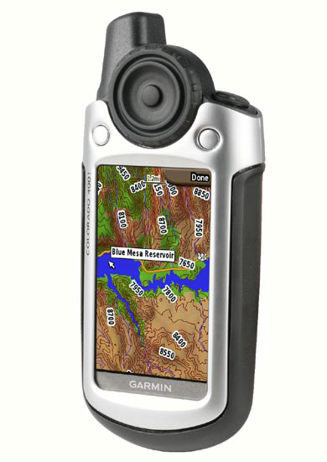

Fig12: GPS MODEM

**Control Segment**

The control segment is responsible for constantly monitoring satellite health, signal integrity, and orbital configuration from the ground control segment includes the following **Sections :**

* Master control station
* Monitor stations
* Ground antennas

**Monitor Stations**

At least six unmanned monitor stations are located around the world. Each station constantly monitors and receives information from the GPS satellites and then sends the orbital and clock information to the master control station (MCS).

**Master Control Station (MCS)**

The MCS) is located near Colorado Springs in Colorado. The MCS constantly receives GPS satellite orbital and clock information from monitor stations. The controllers in the MCS make precise corrections to the data as necessary, and send the information (known as ephemeris data) to the GPS satellites using the ground antennas.

**Ground Antennas**

Ground antennas receive the corrected orbital and clock information from the MCS, and then send the corrected information to the appropriate satellites.

**User Segment**

The GPS user segment consists of your GPS receiver. Your receiver collects and processes signals from the GPS satellites that are in view and then uses that information to determine and display your location, speed, time, and so forth. Your GPS receiver does not transmit any information back to the satellites.

**How Does GPS Technology Work?**

The following points provide a summary of the technology at work:

* The control segment constantly monitors the GPS constellation and uploads information to satellites to provide maximum user accuracy
* Your GPS receiver collects information from the GPS satellites that are in view.
* Your GPS receiver accounts for errors. For more information, refer to the Sources of Errors.
* Your GPS receiver determines your current location, velocity, and time.
* Your GPS receiver displays the applicable information on the screen.

**Who Uses GPS?**

GPS technology has many amazing applications on land, at sea, and in the air. You might be surprised to learn about the following examples of how people or professions are already using GPS technology

**Agriculture**

In precision farming, GPS technology helps monitor the application of fertilizer and pesticides. GPS technology also provides location information that helps farmers plow, harvest, map fields, and mark areas of disease or weed infestation.

**Aviation**

Aircraft pilots use GPS technology for en route navigation and airport approaches. Satellite navigation provides accurate aircraft location anywhere on or near the earth.

**Environment**

GPS technology helps survey disaster areas and maps the movement of environmental phenomena (such as forest fires, oil spills, or hurricanes). It is even possible to find locations that have been submerged or altered by natural disasters.

**Ground Transportation**

GPS technology helps with automatic vehicle location and in-vehicle navigation systems. Many navigation systems show the vehicle’s location on an electronic street map, allowing drivers to keep track of where they are and to look up other destinations. Some systems automatically create a route and give turn-by-turn directions. GPS technology also helps monitor and plan routes for delivery vans and emergency vehicles.

**Marine**

GPS technology helps with marine navigation, traffic routing, underwater surveying, navigational hazard location, and mapping. Commercial fishing fleets use it to navigate to optimum fishing locations and to track fish migrations.

**Military**

Military aircraft, ships, submarines, tanks, jeeps, and equipment use GPS technology for many purposes including basic navigation, target designation, close air support, weapon technology, and rendezvous.

**Public Safety**

Emergency and other specialty fleets use satellite navigation for location and status information.

**Rail**

Precise knowledge of train location is essential to prevent collisions, maintain smooth traffic flow, and minimize costly delays. Digital maps and onboard inertial units allow fully-automated train control.

**Recreation**

Outdoor and exercise enthusiasts use GPS technology to stay apprised of location, heading, bearing, speed, distance, and time. In addition, they can accurately mark and record any location and return to that precise spot.

**Space**

GPS technology helps track and control satellites in orbit. Future booster rockets and reusable launch vehicles will launch, orbit the earth. Return, and land, all under automatic control. Space shuttles also use GPS navigation.

**Surveying**

Surveyors use GPS technology for simple tasks (such as defining property lines) or for complex tasks (such as building infrastructures in urban centers). Locating a precise point of reference used to be very time consuming. With GPS technology, two people can survey dozens of control points in an hour. Surveying and mapping roads and rail systems can also be accomplished from mobile platforms to save time and money.

**Timing**

Delivering precise time to any user is one of the most important functions of GPS technology. This technology helps synchronize clocks events around the world. Pager companies depend on GPS satellites to synchronize the transmission of information throughout their systems. Investment banking firms rely on this service every day to record international transactions simultaneously.

**How Accurate Is GPS?**

GPS technology depends on the accuracy of signals that travel from GPS satellites to a GPS receiver. You can increase accuracy by ensuring that when you use (or at least when you turn on) your GPS receiver, you are in an area with few or no obstacles between you and the wide open sky. When you first turn on your GPS receiver, stand in an open area for a few moments to allow the unit to get a good fix on the satellites (especially if you are heading into an obstructed area). This gives you better accuracy for a longer period of time (about 4-6 hours).

It takes between 65 and 85 milliseconds for a signal to travel from GPS satellite to a GPS receiver on the surface of the earth.

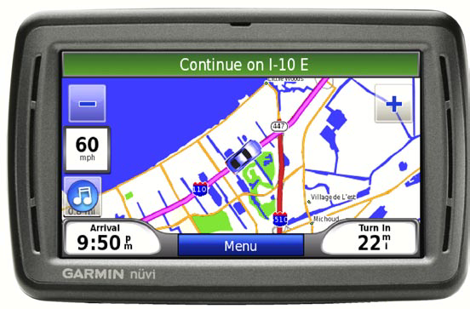

FIG 13: GPS sample module (GARMIN)

The signals are so accurate that time can be figured to much less than a millionth of a second, velocity can be figured to within a fraction of a mile per hour, and location can be figured to within a few meters.

**WAAS/EGNOS**

The Wide Area Augmentation System (WAAS) is a system of satellites and ground stations that provides even better position accuracy than the already highly accurate GPS. Europe’s version of this system is the European Geostationary Navigation Overlay Service (EGNOS). The Federal Aviation Administration (FAA) developed the WAAS program. It makes more airspace usable to pilots, provides more direct end route paths, and provides new precision approach services to runways, resulting in safety and capacity improvements in all weather conditions at all locations throughout the U.S. National Airspace System (NAS).Although it was designed for aviation users, WAAS supports a wide variety of other uses, for example, more precise marine navigation. To take advantage of WAAS technology, you must have a WAAS-capable GPS receiver in an area where WAAS satellite coverage is available such as North America. No additional equipment or fees are required to take advantage of WAAS.

**Sources of Errors**

Errors can affect the accuracy of the GPS signal. Take your GPS receiver to an area with a wide and unobstructed view of the sky to reduce the possibility and impact of some errors. Here are some of the most common GPS errors.

**Ionosphere and Troposphere Delays**

The satellite signal slows down as it passes through the atmosphere. The system uses a built-in model that calculates an average delay to partially correct this type of error.

**Software**

Whether you want to save your favorite locations or plan a trip, map software can help. You can use your PC or go directly your GPS receiver. Your preference for map detail and your specific activities determine which software is right for you.

**Complementary Navigation Aids**

Remember, a GPS receiver is a complement to navigation and should not be the only navigational tool that you use. Using a paper map, a simple compass, and having knowledge of manual navigation is a good, safe practice.

**Pin Assignment**

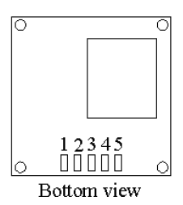



Fig: GPS 3A pin assignment

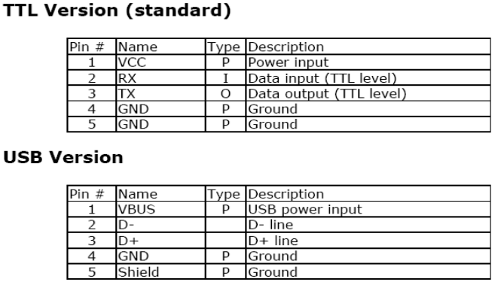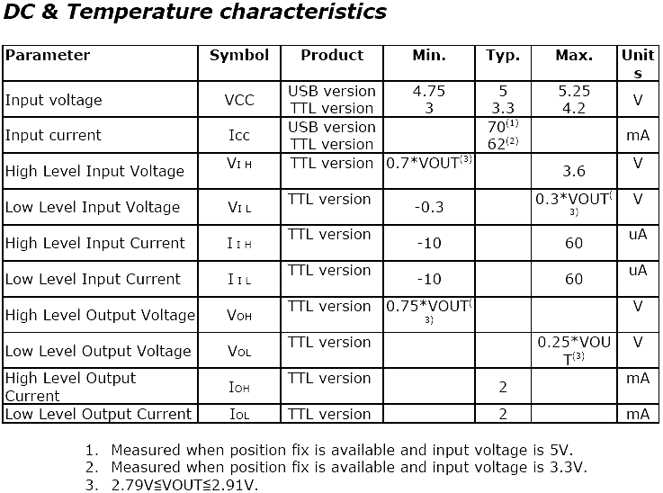



**GPS Interfacing with Raspberry Pi:**

GPS (Global Positioning System) interfacing with the Raspberry Pi has become increasingly popular for a wide range of applications, from navigation and location-based services to tracking and geospatial data analysis. The Raspberry Pi, with its GPIO pins and the capability to run Python scripts, is an ideal platform for connecting to GPS modules. By integrating a GPS module such as the popular NEO-6M, Raspberry Pi users can access accurate real-time geographic data, including latitude, longitude, altitude, and precise time information. This data can be harnessed for diverse projects, like creating interactive maps, developing vehicle tracking systems, or even implementing geofencing for IOT devices. The versatility of Raspberry Pi, combined with the accuracy and reliability of GPS, opens up a world of possibilities for hobbyists and professionals looking to incorporate location-based intelligence into their projects.

GPS interfacing with Raspberry Pi offers an exceptional foundation for location-based applications. The Raspberry Pi's compatibility with a variety of GPS modules, such as the Ublox NEO-6M or Adafruit Ultimate GPS, allows developers to harness the power of global positioning technology. This integration is particularly valuable in fields like drone navigation, marine navigation, precision agriculture, and environmental monitoring. By accessing the NMEA data stream from the GPS module through the Raspberry Pi's GPIO pins, users can not only determine their precise location but also access critical information like speed, heading, and the number of visible satellites. The combination of Python programming and the extensive community support for Raspberry Pi makes it relatively easy to create custom applications that use this GPS data, from creating GPS-guided robots to setting up real-time location-based weather stations. Moreover, the Raspberry Pi's compact form factor, low power consumption, and affordability make it an attractive choice for embedded GPS solutions that require continuous, autonomous operation.

